* Introduction
* -Database Description
  + Logical Design (include a PNG of your ERD in this section)

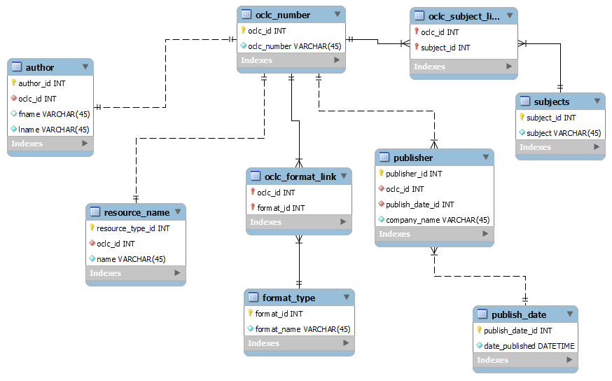

* + Physical Database
  + Sample Data
  + Views / Queries

| View Name | Req. A | Req. B | Req. C | Req. D | Req. E |
| --- | --- | --- | --- | --- | --- |
| routledge_authors | X | X |  |  | X |
| hard_copy_books | X | X | X |  |  |
| no_author_publisher | X | X | X |  |  |
| oclc_online_works | X | X |  | X |  |
| recorded_author_works | X | X |  | X |  |

* Changes from original design
* Lessons Learned
* Potential Future Work